Assignment 1

CSIS 1175

(10 marks in total)

1. Re-write the CarpetCalculator app using class methods.
2. Print “Douglas” on console screen. The reference output is posted below(your result can be different)

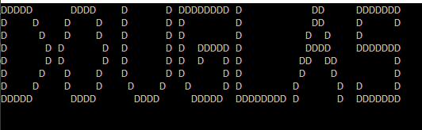

1. Question 2 on page 134.
2. Question 6 on page 135.
3. Question 4 on page 195.
4. Question 6 on Page 195.

**Submission**

You need to submit your assignment through Blackboard community by the due date. NO LATE SUBMISSION will be allowed.

Please copy all projects in one folder and assign each project an individual sub-folder. Then compress the folder and name it as **asignment1-studentID**.zip. If not zipped as .zip folder, 5% penalty will be applied.

You may submit your work multiple times, but only the last submission will be graded.